Maintaining Image Proportion

Using Adobe Photoshop

1) Click > File > Open

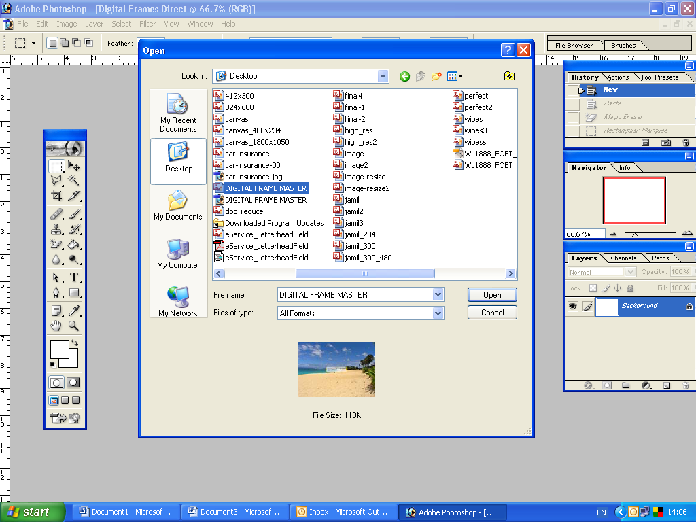

From here you need to select the image you want to edit and click > open

Our image size is 960 pixels x 1280 pixels – if we use this image with our digital frame it will look similar to display A or B.

Display A |  | Display B
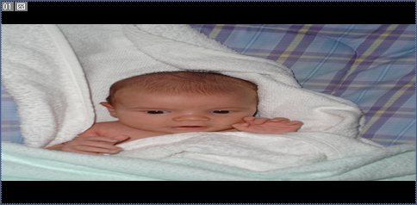 | Or | 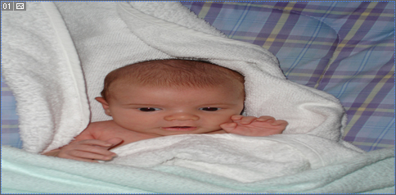

We will optimise this image so the Image maintains its proportion as well as quality.
Please note this will result in losing some part of the Image

2). Photoshop will open a New Window displaying your image
Click > Select > All
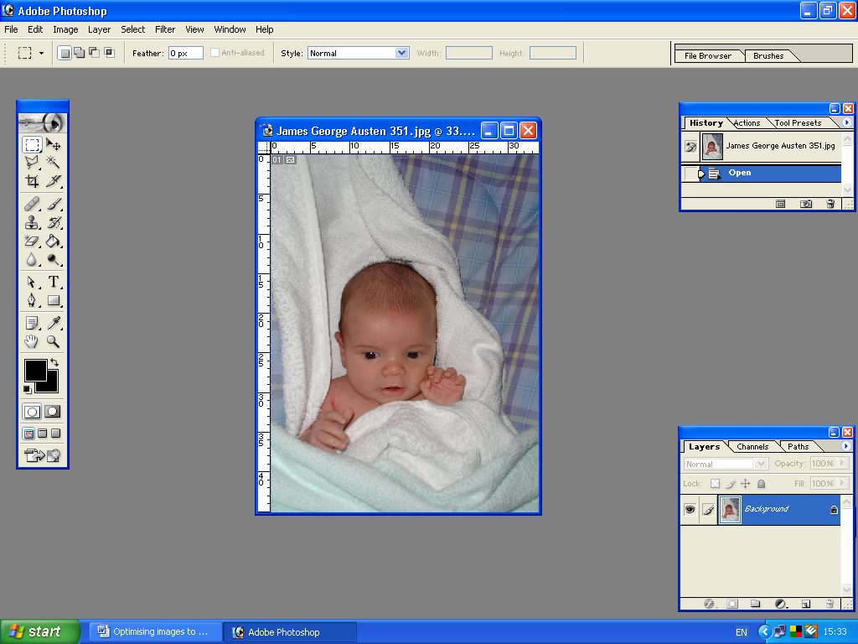
3) Click > Edit > Cut

4) Now you need to open a new work area. Click > File > New

When the New box appears it is important that you fill in the fields with the following details:
 | 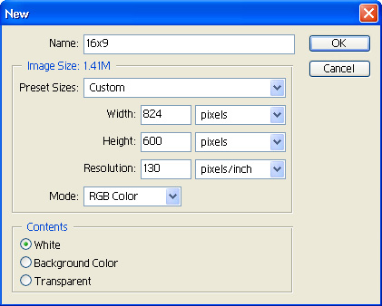
  Name | - | Any
  Width | - | 824 Pixels
  Height | - | 600 pixels
  Resolution | - | 130 pixels/inch

And Click > OK
You will see a blank work area, which is the known as the Canvas you will paste and re-map the image on the work area.

Only drop the area of image on the canvas, which you want to see on the digital frame display.

5) Click > Edit > Paste

6) Using the Mouse you need to drag and drop the image on the canvas as required suiting your needs.

Please note – you will only see what is within the work area as shown in sample A & B.

Sample A | Sample B
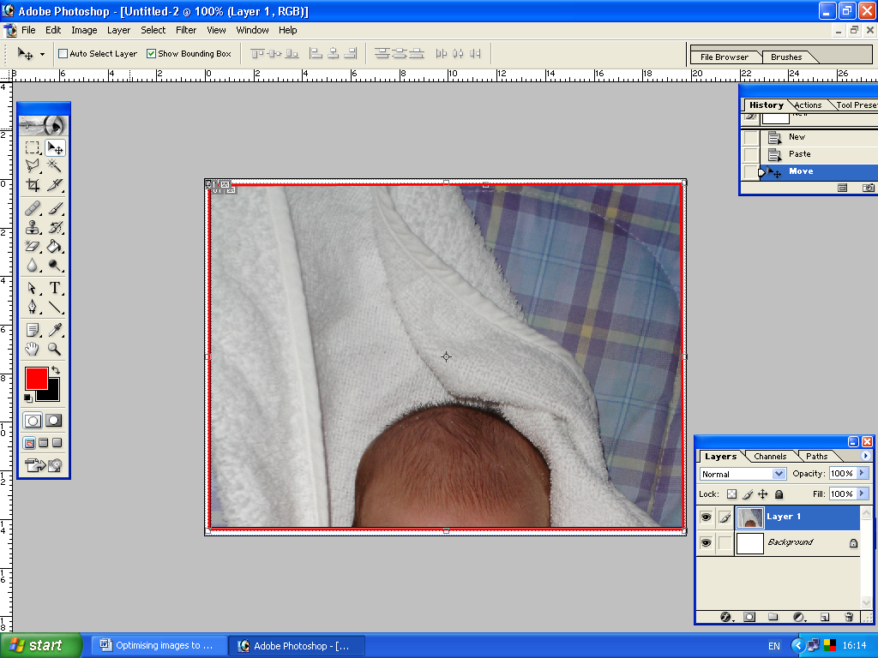 | 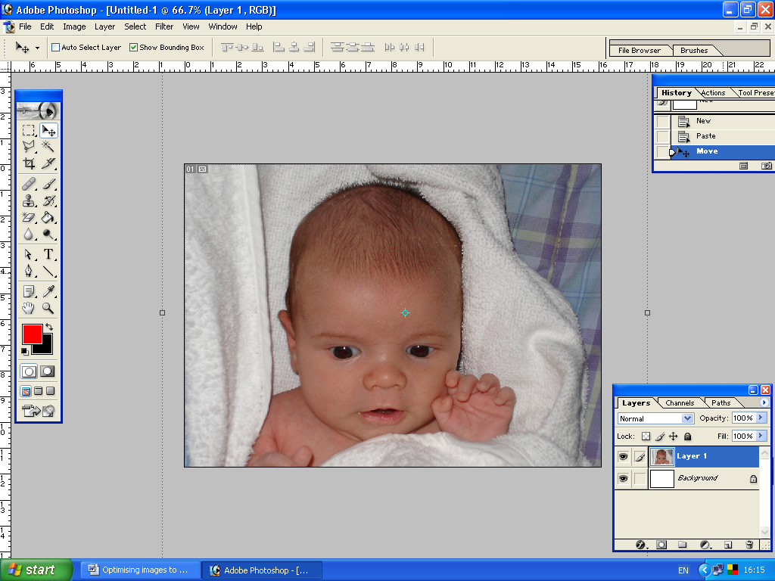

Once you have successfully dragged the image on the work area to suit you, you will need to flatten the image.

7) Click > Layer > Flatten Image

You are now ready to save your image – it is important to save your image as an jpeg file format

8) Click > File> Save as – Name your image and from the Format dropdown option select > jpeg and click save.
You have successfully optimised your image to fit the 7” Digital Frame maintaining quality and the proportion of the image.

What If you’re using a high-resolution image?

High resolution – image is taken with a digital camera, which has more than 5.0 mega pixels. The image is much larger than the example shown above with resolution at 300 pixels/inch and excellent picture quality.

- Click > File > Open

From here you need to select the image you want to edit and click > open

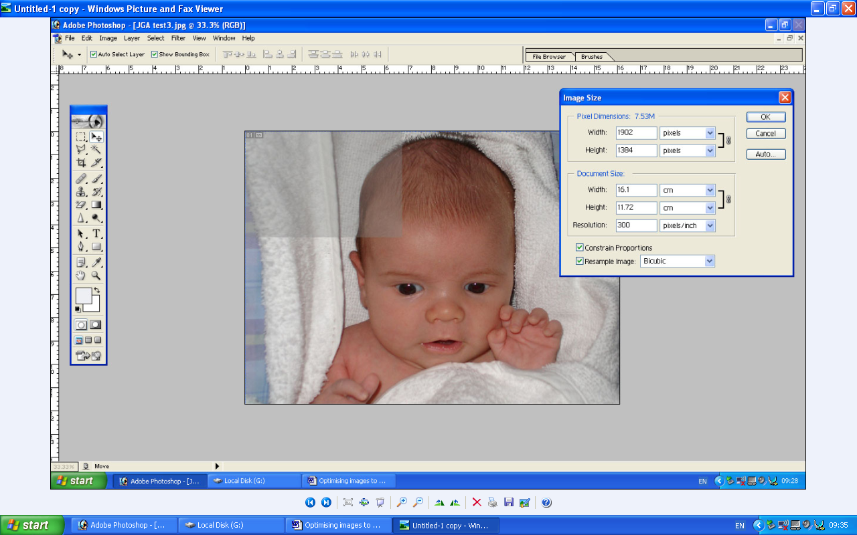

Our image size is 1902 pixels x 1384 pixels with resolution at 300 pixels/inch – if we use this image with our example above we would only see less than a quarter of the image as highlighted in grey.

We need to optimise the image so it fits the digital frame display without losing too much of the original image area.

2) Select > Image > Image size

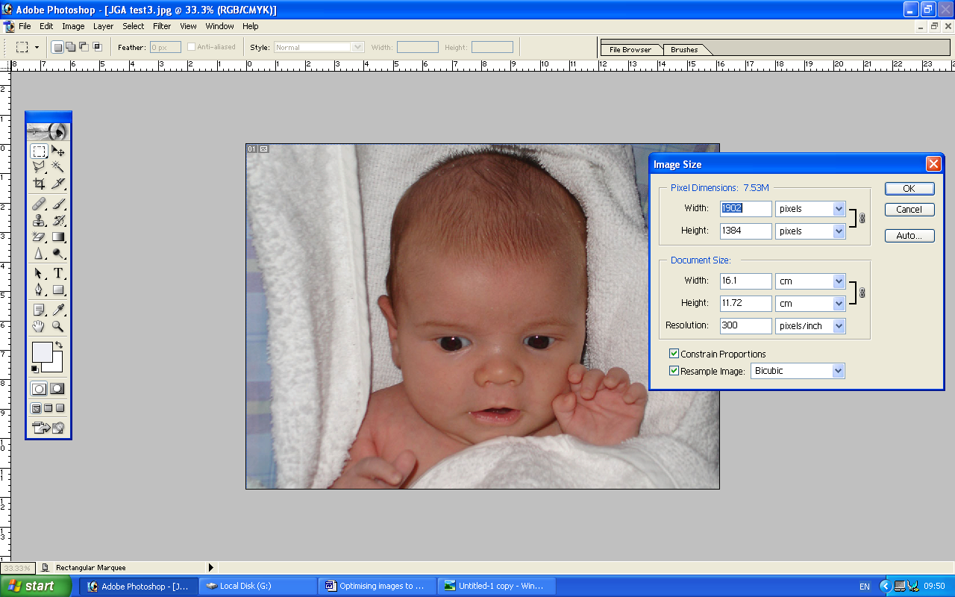

Image size box will appear showing pixel dimensions and the size of the image. You will be able to tell what the resolution is of the image that you are working with.

3) Ensure the constrain proportion tick box is selected, which is located at the bottom of the image size box.

From the pixel dimension change the width to 950 pixels and the height will automatically change to 691 pixels.

When optimising a high-resolution image it is important that you keep the pixel dimensions above 824 pixels wide and 600 pixels height as this will be the area, which your digital frame will display.

4) Now de-select constrain proportion option and change the resolution to 130 pixels/inch and select > OK.

5) Now Click > Select > all

6) Edit > Cut
7) Now you need to open a new work area. Click > File > New

When the New box appears it is important that you fill in the fields with the following details:
Name | - | Any
Width | - | 824 Pixels
Height | - | 600 pixels
Resolution | - | 130 pixels/inch

And Click > OK
You will see a blank work area, which is the known as the Canvas you will paste and re-map the image on the work area.

Only drop the area of image on the canvas, which you want to see on the digital frame display.

8) Click > Edit > Paste

9) Using the Mouse you need to drag and drop the image on the canvas as required suiting your needs.

Once you have successfully dragged the image on the work area to suit you, you will need to flatten the image.

10) Click > Layer > Flatten Image

You are now ready to save your image – it is important to save your image as an jpeg file format

11) Click > File> Save as – Name your image and from the Format dropdown option select > jpeg and click save.
You have successfully optimised your image to fit the 7” Digital Frame maintaining quality and the proportion of the image.

